20250121 BJ

Selection toward items based on augmented mutual information

LiFeng Liu，Shanghai University
QiNan Xu， Zhoukou Normal University
XuXia Zhao，China Petroleum University
Ping Cheng，Shanghai University

Abstract: We present a recommendation methodology based on weighted mutual information. Contextualizing data augmentation, collaborative filtering, and deep learning, highlights their shortcomings: noise introduction, adaptation to sparse data, and high-complexity parameters. We developed a smoothing coefficient-enhanced mutual information metric to model the relationships among user behavior, item titles, and augmentations. This approach utilizes a semantic network to uncover intrinsic meanings, with corresponding weights assigned based on their importance.

Finally, experimental validation demonstrates that the proposed method significantly outperforms traditional recommendation algorithms in small sample data scenarios, showcasing notable advantages in both accuracy and practicality. This research not only provides innovative insights for improving the performance of recommendation systems in sparse data environments but also offers a viable approach and solution for personalized recommendation technologies in real-world applications.
Keywords: Recommendation Systems; Small Sample Data; Mutual Information; Smoothing Coefficient-enhanced；Semantic Network.
1. Introduction
Recommendation systems are widely used across various fields, such as e-commerce, social platforms, and online education[1][2]. The goal of recommendation systems is to analyze users' historical behavior data to predict their future interests, improving user experience and furthering platform goals. However, in many real-world applications, recommendation systems face data sparsity, especially in situations with limited data samples.
Traditional recommendation methods, such as collaborative filtering and content-based recommendation, work well in large data environments but often encounter significant performance bottlenecks in small sample data scenarios. Collaborative filtering recommends based on analyzing the interaction matrix between users and items. However, when data is sparse, it fails to capture the underlying relationships between users and items[3]. Content-based methods, on the other hand, rely on the feature information of items, which can be difficult to extract accurately when sufficient historical data is unavailable[4]. Furthermore, while deep learning techniques can capture complex nonlinear relationships, they generally require large amounts of training data to perform effectively[5], and are prone to overfitting when applied to small sample data[6].
In recommendation system research, small sample data refers to situations where there are limited samples and only a few features are available. To address the issue of small sample data, existing research has mainly relied on data augmentation, meta-learning approaches, and reinforcement learning models. Data augmentation attempts to generate more samples to increase model robustness[7], but it often introduces noise, which can decrease recommendation quality. Meta-learning can effectively address data sparsity and overfitting problems, improving the accuracy and efficiency of recommendation algorithms, especially when user or item information is scarce[8]. However, meta-learning often requires more complex model structures, leading to high computational costs and making the models difficult to debug and interpret. Reinforcement learning, which does not rely on large amounts of labeled data, can adjust and optimize recommendations through continuous interaction with the environment, improving recommendation performance with limited data[9]. However, reinforcement learning may struggle to quickly adapt to rapidly changing user behaviors, especially when there is insufficient historical data, and the model may be prone to data noise. In summary, these methods still struggle to achieve satisfactory performance in sparse data environments.
To address the small sample data problem, this study proposes a recommendation system method based on weighted mutual information (MI). Mutual information is a metric used to measure the correlation between two variables and is widely applied in information theory[10]. Compared to traditional similarity-based methods used in recommendation systems, mutual information can better uncover potential relationships between items by capturing weaker signals[11][12]. Furthermore, to address the issue of unstable mutual information values in sparse data that can lead to incorrect recommendations, this study introduces a smoothing coefficient (SC) factor in the MI metric. The smoothing coefficient helps reduce the noise caused by data sparsity, enhancing the stability of similarity calculations. Specifically, the smoothing coefficient is a dynamic adjustment factor based on data sparsity. When an item or user has sparse rating data, the smoothing coefficient increases its weight in similarity calculations with other items or users, thus alleviating the impact of data sparsity on recommendation accuracy.
This study focuses on small sample data scenarios and integrates international research findings on recommendation systems, proposing a weighted mutual information recommendation system. The main contributions and innovations of this study are summarized as follows:
(1)Data Preprocessing in Limited Data Scenarios: Comprehensive data preprocessing steps are applied when dealing with limited data, including processing user behavior, product information, and product tags.
(2)Algorithmic Recommendations Based on Different Data Sources: This study recommends products based on various algorithms and different data sources, such as user behavior, product titles, and product tags. Each data type is assigned a different weight to enhance the recommendation process.
(3)Integration of Mutual Information and Smoothing Coefficient: Mutual information is used as a method to measure item similarity. To address the sensitivity of small sample data to sparsity, a smoothing coefficient factor is introduced into the mutual information calculation. This addition aims to mitigate the impact of data sparsity on recommendation accuracy.
(4)Comparative Experiments with Various Algorithms: Comprehensive comparative experiments are conducted between the proposed weighted mutual information method and other recommendation algorithms, including collaborative filtering, content-based algorithms, and deep learning-based methods. The comparative analysis aims to provide insights into the relative performance of each method in small sample data scenarios.
By combining these elements, this study aims to provide a new approach to recommendation systems in limited data environments, making a valuable contribution to the field.

2. Related Work
Recommendation systems, as a crucial component of information services, have long been dedicated to alleviating information overload and providing personalized recommendations. They have become indispensable tools in various fields such as e-commerce, social platforms, and online education. Particularly in scenarios involving small sample data, recommendation systems face challenges related to data sparsity. Many researchers have conducted extensive studies to improve the generalization and effectiveness of these models. Against this backdrop, this paper summarizes the development and limitations of several major recommendation methods, aiming to provide a theoretical foundation and highlight the innovations of this study.
Collaborative filtering, one of the earliest and most classic recommendation algorithms, is widely applied to analyze user-item interaction data. Traditional collaborative filtering identifies similar users or items by analyzing the user-item interaction matrix to make personalized recommendations. Goldberg et al. pioneered the application of this method in email filtering systems in 1992, marking the inception of collaborative filtering research[13]. Subsequently, Sarwar et al. proposed item-based collaborative filtering, which identifies relationships between items within the user-item matrix and leverages these relationships for recommendations[14]. Su et al. explored how to predict user preferences for item ratings based on the preferences of specific user groups, thereby improving recommendation accuracy[15]. Bobadilla et al. reviewed the development of collaborative filtering methods and proposed various innovative techniques to enhance recommendation performance[16]. Despite its success in large-scale data environments, collaborative filtering faces significant challenges in small sample data scenarios, particularly regarding data sparsity. When user-item interaction records are sparse, collaborative filtering often struggles to accurately capture users, latent interests, leading to suboptimal recommendation performance. Nevertheless, collaborative filtering remains effective in handling large-scale datasets, especially for popular items, although its performance is less satisfactory for long-tail items.
In addition to collaborative filtering, content-based recommendation methods are another common strategy. These methods analyze the attributes of items and match them to users’ interests to recommend relevant products. Pazzani et al. elaborated on the architecture of content-based recommendation strategies and their applications in fields such as web page and TV program recommendations[17]. Lops et al. provided a comprehensive overview of content-based algorithms, summarizing their processes and recent advancements[18]. Beel et al. analyzed the advantages and limitations of content-based methods, highlighting their dominant role in personalized recommendations[19]. Reddy et al. proposed an improved content filtering recommendation algorithm, achieving positive results[20].While content-based methods effectively utilize item features for recommendations, they face several challenges. First, when historical data is insufficient, extracting item features can be inaccurate, resulting in lower recommendation quality. Additionally, these methods are prone to "feature bias" as they rely heavily on explicit item attributes and often overlook users’ implicit preferences. Consequently, the performance of content-based methods in small sample data scenarios remains limited, especially when feature information is incomplete or insufficient.
With the rapid advancement of deep learning technologies, methods based on deep neural networks have emerged as a key focus in recommendation system research. Deep learning models are capable of capturing complex user-item relationships and are widely applied in various recommendation tasks. For example, Cheng et al. introduced the “Wide & Deep Learning” method, which combines breadth and depth in deep learning to better capture users’ latent interests[21]. Zhang et al. proposed a new model based on existing deep learning recommendation models and provided insights into the evolving trends of deep learning in recommendation systems[22]. Although deep learning significantly improves recommendation performance, it also presents considerable challenges, particularly the need for large amounts of training data[23][24]. Deep neural networks require extensive labeled data for effective training and optimization, which poses a major obstacle in small sample data scenarios[25]. Additionally, deep learning models are computationally intensive and prone to overfitting, especially in sparse data environments. While deep learning methods excel in handling large-scale data, their application in small sample recommendation systems remains constrained by data scarcity and computational resource requirements.
Beyond the aforementioned approaches, many scholars have conducted extensive reviews of recommendation system methodologies. Ko H et al. analyzed over 135 top-tier articles, offering a thorough statistical overview of recommendation system techniques and trends, providing valuable insights for future research[26]. Meng Yu et al. provided a detailed overview of the current state of recommendation systems, with a particular focus on the research progress of deep learning-based models[27]. They also explored challenges faced by recommendation systems and discussed potential future directions. Furthermore, several studies have delved into similarity methods in recommendation systems. Sondur et al. reviewed commonly used similarity metrics and experimentally compared their applications, highlighting the importance of similarity methods in recommendation systems[28]. Fethi Fkih et al. conducted a detailed analysis of similarity measurements in collaborative filtering-based systems, emphasizing their critical role in recommendation algorithms through experiments on public datasets[29]. These studies have inspired a range of research directions and methodologies for subsequent scholars.
The methods discussed above have demonstrated strong performance in large-scale data environments but continue to face limitations in small sample data scenarios. In contrast to previous research, this study proposes an innovative weighted mutual information method that dynamically adjusts smoothing coefficients in similarity calculations to address data sparsity in small sample settings. Compared to traditional collaborative filtering and content-based methods, the proposed approach better captures latent relationships between users and items, improving both recommendation accuracy and coverage. Importantly, this method does not rely on large-scale labeled data but instead optimizes mutual information metrics to perform effective recommendations using limited data, offering substantial practical value.
In summary, while existing recommendation methods have partially addressed issues of recommendation performance and data sparsity, challenges remain in small sample data environments. With the introduction of the weighted mutual information method, this study not only offers a novel solution but also provides valuable insights for the future development of recommendation systems.

3. Several commonly used recommendation algorithms
3.1. Collaborative filtering recommendation algorithm
The collaborative filtering algorithm stands as a classic and widely utilized method in recommendation systems. At its core, this algorithm mines user preferences based on historical behavior data to predict recommended products that users are likely to prefer. Collaborative filtering can be categorized into two parts: online collaborative filtering and offline filtering. Online collaboration utilizes real-time data to identify items that users may like, whereas offline filtering eliminates data deemed unworthy of recommendation, such as items with low recommendation scores or those that users have already purchased.
Collaborative filtering models typically involve m items and n user data, where only some users and some data have rating data, leaving other ratings as missing values. In this scenario, existing sparse data is leveraged to predict the rating relationship between blank items and data, aiming to identify the most suitable high-rating items for recommendation to users.
Collaborative filtering recommendations are primarily divided into three types: user-based, item-based, and model-based. User-based collaborative filtering centers on the similarity between users[30], discovering preferences of similar users to predict the target user's rating for the corresponding item, thus recommending the highest-rated items. Item-based collaborative filtering, akin to user-based methods, seeks similarities between items[31], predicting similar items through users' ratings of certain items and recommending highly rated items accordingly. Model-based collaborative filtering comprehensively considers the relationship between users and items, constructing a model to predict the rating relationship and achieve personalized recommendations. In essence, the collaborative filtering algorithm predicts the user's rating relationship for items by analyzing historical behavior data, thereby recommending items that align with user interests and possess higher ratings.
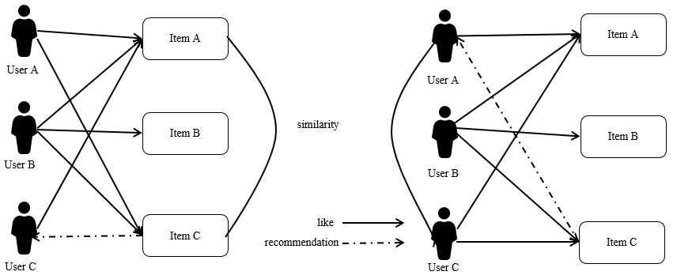
Figure 1. Item-based collaborative filtering algorithm and user-based collaborative filtering algorithm
Figure 1 illustrates the principles of item-based and user-based collaborative filtering. On the left side of the figure, item-based collaborative filtering is depicted. Assuming that user A likes item A and item C, user B likes item A, item B, and item C, and user C likes item A. By analyzing the preferences of these users, it can be inferred that item A and item C exhibit relative similarity, indicating that users who like item A are likely to also favor item C. Utilizing this data, it can further be inferred that user C is likely to have an interest in item C. Consequently, the system will recommend item C to user C. User-based collaborative filtering operates in a similar manner.
3.2. Content-based recommendation algorithm
The content-based recommendation system initially evolved as an enhancement to the collaborative filtering algorithm. Collaborative filtering, in its basic form, considers only the user's rating of the item, overlooking the various attributes inherent in the item itself. For instance, in the case of an item like a car tire, its attribute characteristics encompass the manufacturer, size, category, and other relevant information. Content-based recommendation addresses this limitation by utilizing these specific attributes for making recommendations[32]. In this recommendation method, content features within items are extracted and subsequently matched with the user's interest tags. Items with a high degree of matching content features can then be recommended to the corresponding user. For example, as shown in Figure.2, if the feature words of text A include "education" and "university," and the feature words of text C also include "education" and "university," these items can be considered similar texts. If user A reads text A and shows interest in educational articles, text C can then be recommended to user A.
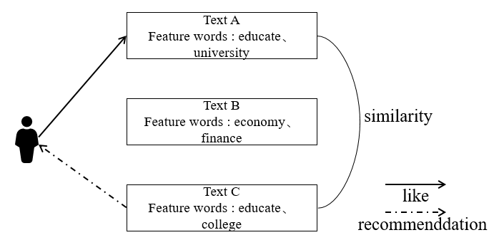
Figure 2. Schematic Diagram of Content-Based Recommendation Algorithm
4. Similarity comparison method
4.1. Traditional similarity comparison method
There are various traditional methods to measure the similarity between items[33][34], with the most representative ones being cosine similarity and the Pearson correlation coefficient. Cosine similarity is a commonly employed similarity measurement method and finds widespread use[35]. It treats the ratings of item  and item  by  users as a vector in dimensions, assessing the similarity between items by calculating the cosine value of the angle between the vectors. Here,  represents user u's rating of item , denotes the set of users who jointly rated item and item j. The calculation formula is as follows:
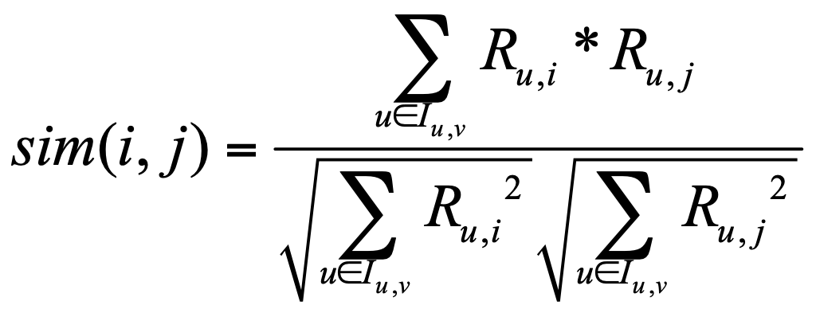 | (1)

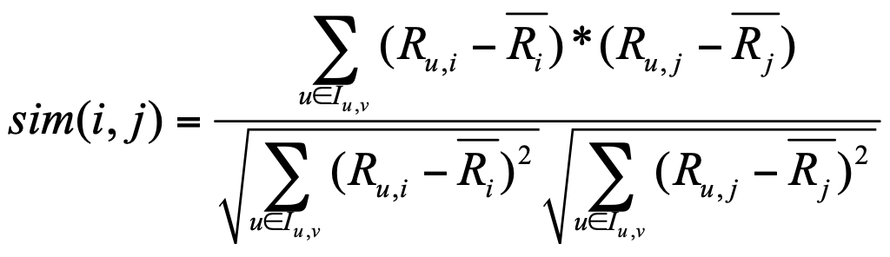 | (2)
The Pearson correlation coefficient measures the similarity between items by calculating the linear relationship between two item score vectors[36][37]. Here,  and  represent the average rating of item and item by users who have jointly rated both items and . The calculation formula is as follows:
In an actual recommendation system, the number of users who have jointly rated items and is typically small, posing a bottleneck for traditional similarity methods. When the number of users who have jointly rated items and is 1, the cosine similarity calculation consistently yields a result of 1, thereby inflating the similarity value between items. The Pearson correlation coefficient overlooks inconsistent scoring standards among users, leading to specific scoring differences for each item. This can result in situations such as the scoring vectors of 5 users for items and being (1, 2, 1, 2, 1) and (4, 5, 4, 5, 4) respectively, with the Pearson coefficient yielding a calculated result of 1. Consequently, it is evident from the above that there is a certain error in the traditional similarity method when calculating the similarity between items.

4.2. Improved mutual information similarity comparison method
 | (3)
Mutual Information is an important information measurement method in information theory[38][39], abbreviated as MI. It can be regarded as the amount of information contained in one random variable about another random variable. It is Indicates whether there is a relationship between two variables X and Y or refers to the degree of correlation between the two variables. In information theory, information entropy is the most common way to measure the purity of a sample set. In information theory, information entropy is the most common indicator to measure the purity of a sample set. It can be expressed as H(X), and its formula is as follows:
In the formula, 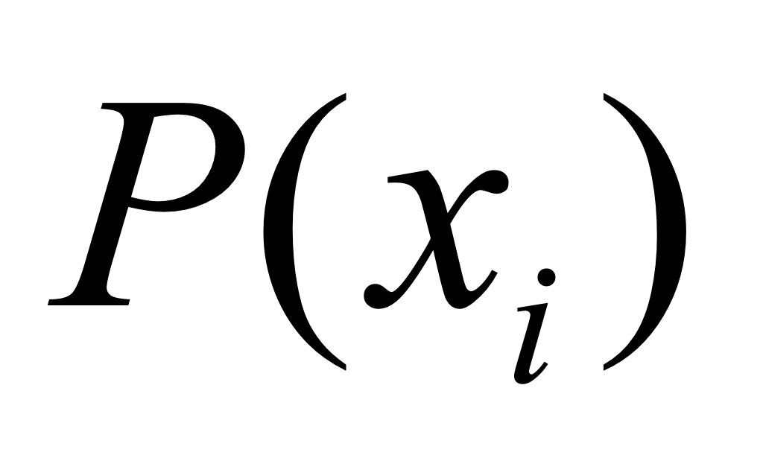 represents the probability of sample , and  is the number of possible samples. To this end, the joint information entropy H(X,Y) of X and Y is introduced:
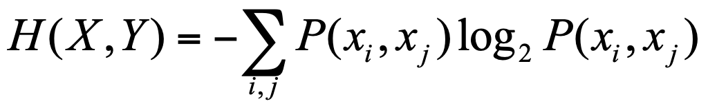 | (4)

 | (5)
For X, due to the occurrence of variable Y and the correlation between the two, the entropy value that reduces its uncertainty is called mutual information, which is defined as:
It can also be expressed as:
(6)

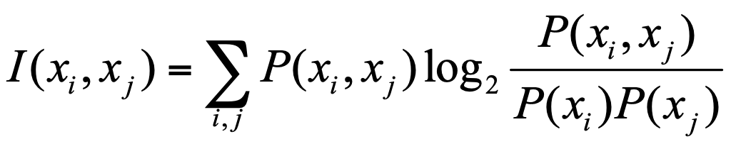 | (7)
Combining equation (3) and equation (6), the final mutual information expression can be obtained as follows.
where 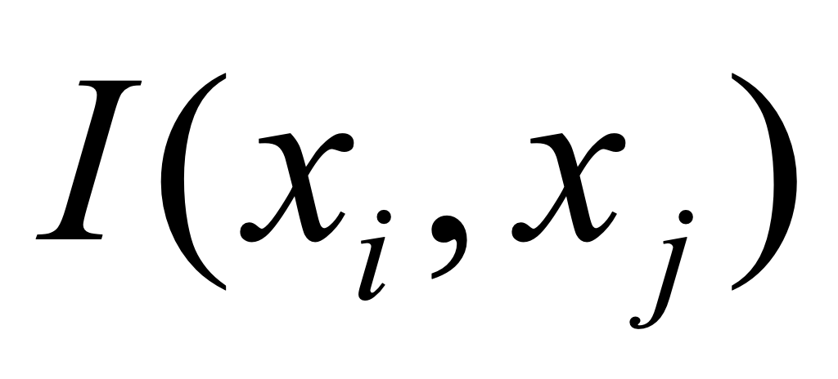 denotes the value of mutual information between and .  is the frequency of co-occurrence of and  , and ,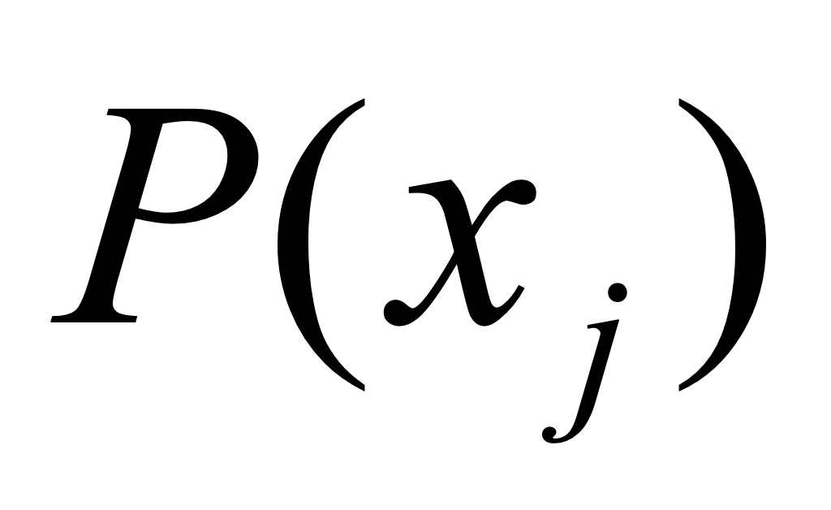is the frequency of occurrence of , individually, respectively. The larger , the stronger the degree of association of , , i.e., the more similar is to .
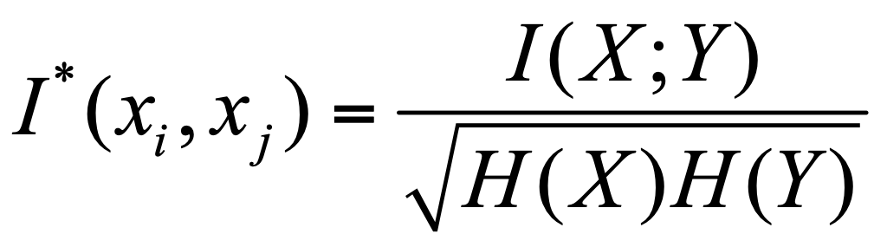 | (8)
In particular, it is pointed out that mutual information does not have any special requirements for the distribution of  and . It can be used to describe the linear relationship between variables. In order to make the value of mutual information between [0,1], normalization processing is required. The formula is as follows:
Consider variable as a vector of project rated by all users, denoted as ; The variable can be regarded as a vector of project being rated by all users, denoted as . The formula for calculating the similarity between items is:
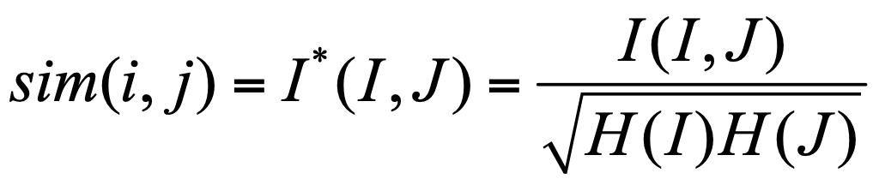 | (9)

In the formula,  is the mutual information value between item and item ;  is the information entropy of item .
In the small sample data of this study, the data sparsity is very serious, resulting in a very small number of project users who jointly rated it. Considering mutual information, we can better explore the correlation degree of two random variables, that is, when a random variable is known, Under the premise, the uncertainty of another random variable is reduced, and a smoothing coefficient factor is introduced to alleviate the problem of data sparsity. For example, the rating vectors of 5 users for item and item are (1, 2, 1, 0,0) and (0,0,5,0,4), using the mutual information method, the similarity value of item and item is 0.1406, indicating that the correlation between the two items is very weak. In the mutual information method after adding the smoothing coefficient, the calculated formula result is 0.0468, indicating that the similarity between the two projects is very low. Compared with the traditional similarity comparison algorithm, this result is more accurate. The formula of the smoothing coefficient is:
 | (10)

The value range of the above smoothing coefficient is [0,1]. When item and item are rated by the same user, the value is 1. When item and item are rated by completely different users, the value is 1. When the value is 0, it is generally expected that the smoothing coefficient will approach 1. At this time, there are more commonly scored items, and the calculation of similarity is more accurate. In addition, the smoothing coefficient is sensitive to overlapping data, that is, it can obtain the relative difference between item and item in user ratings. Therefore, in small sample data, it can well reflect the similarity between items. According to the formula (9) and formula (10), the final similarity measure formula can be obtained as:
(11)

In the formula, and represent different items respectively,  is the number of users who jointly evaluate items and ,  is the number of users who rated item by all users,  is the number of users who rated item by all users Rating,  is the normalized mutual information value of item and item .

5. Weighted mutual information recommendation algorithm
5.1. Recommendation methods based on user behavior
User behavior includes historical behaviors such as user browsing records, user collections, purchase records, and comment information. Because these behaviors have different impacts on users, the user browsing records here are recorded as , and the distribution weight is 1; the user collection behavior is recorded as , and the distribution weight is 2; the purchase behavior is recorded as , and the assigned weight is 3. All the user's behaviors towards the product are recorded as , which represents the i-th user's behavior towards the j-th product, which can be written as:
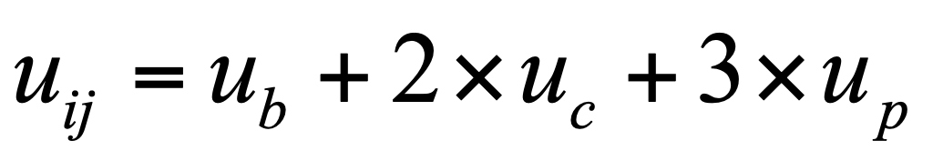 | (12)

Through the above formula, the user's behavior results for the product can be obtained, and finally a user-product matrix is obtained. The specific calculation steps are as follows:
- Data description
The input data is a new  user product matrix S, as shown in Figure 3, m refers to the number of users, n refers to the number of products, and in the matrix represents the behavior of the i-th user towards the j-th product.
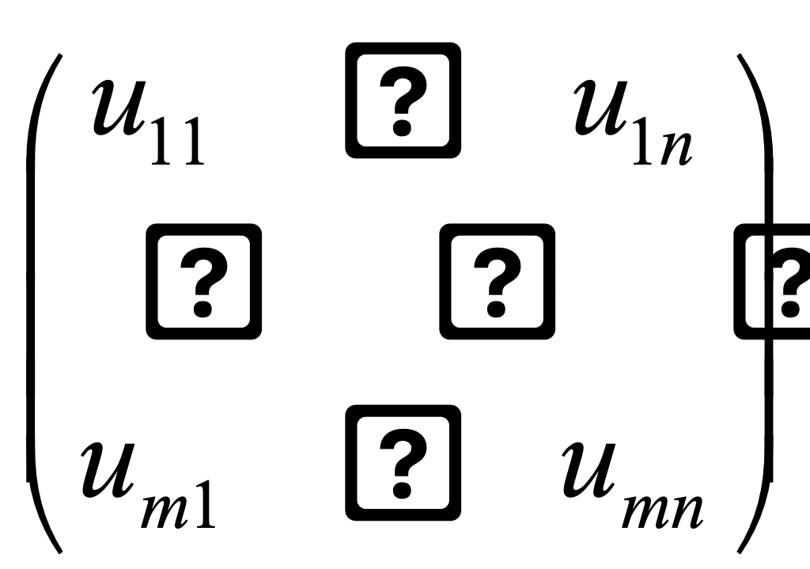
Figure.3 User product matrix S
- Calculate similarity using mutual information
Using formula (11), the similarity between items is calculated based on mutual information.
- Generate recommendation collection
Sort according to the similarity, and put the number and similarity of the top item with the greatest similarity into the recommendation list set, here marked as A, and its form is as follows:
(13)

5.2. Recommendation method based on product title
The title serves as a concise description of a product, capable of summarizing its features accurately, as exemplified by the "Chemeihui tire coating brightener," which highlights the product's three-in-one functions of cleaning, polishing, and protection. While titles can be valuable for recommendations, many are overly lengthy and contain excessive information, making it challenging to base recommendations solely on them. To address this, the article proposes the extraction of all nouns through syntactic analysis. Since most nouns offer clear guidance, including product names, they can effectively filter out extraneous information. For instance, consider the title "Ionic high-foaming car wash liquid 20L, ratio 1:100 (produced by Dingzhong), guaranteed quality, free door-to-door delivery, and generous gifts for new year orders." Although the product is a car wash liquid, the title contains considerable irrelevant details. Filtering out non-essential nouns can help eliminate interference, making recommendations more focused and relevant.
To accomplish this, the title requires processing. The processing steps outlined in this article are as follows:
(1) Preprocess the title corpus, construct a custom word segmentation dictionary based on data characteristics, and use syntactic analysis to extract all nouns;
(2) Keep all the extracted nouns and re-form the title.
(3) Carry out word segmentation on the processed title, and split all the words in the title, such as Chery Tiggo Pedal, into 1 word, 2 words, 3 words, etc., so as to facilitate analysis and comparison.
(4) Count the number of occurrences of each segment under each title, form a vector matrix based on the number of occurrences, and obtain the product-title matrix, as shown in Figure 4:
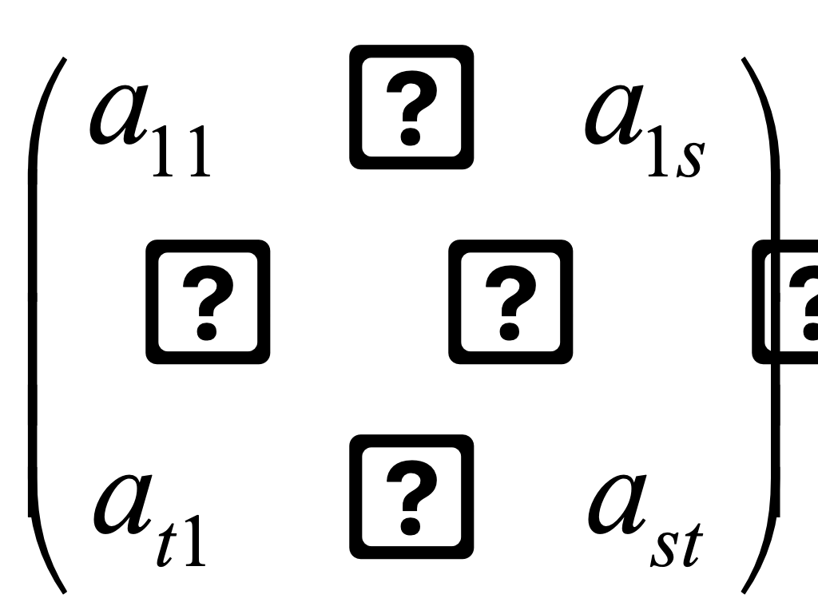
Figure. 4 Product-Title Matrix
(5) Use formula (11), incorporate it into the matrix, calculate the similarity between the products, and obtain the recommended list set based on the magnitude, denoted as B here, with its shape as depicted in A.
5.3. Recommendation method based on product tags
Tags can identify a product, so they can also be considered as a crucial factor in product recommendations. This article initially determines the labels for the products. The selection includes the store ID, brand ID, and category ID of the product, along with whether it originates from the official flagship store. Due to the significant variations in the values of store ID, brand ID, and category ID, normalization is necessary. Data regarding whether the product comes from the official store is marked on a binary scale of 0-1: if present, it is recorded as 1; if not, it is recorded as 0. The final processed data is rep-resented using a vector model, forming a product-label matrix, as shown in Table 1.
Table 1. Data format after product tag processing
Item | Store Id | brand Id | category Id | Is official
item1 | 1 | 20 | 5 | 0
item2 | 2 | 17 | 7 | 1
item3 | 3 | 37 | 6 | 1
… | … | … | … | …
… | … | … | … | …

Convert the above table into a matrix, normalize it, input the data into formula (11), and obtain the recommended list set based on similarity, in the format shown in A, recorded as C.
Considering the above three recommendation methods comprehensively and assigning different weights, the recommendation results based on user behavior are assigned a weight of , the recommendation results based on product titles are assigned a weight of , and the recommendation results based on product tags are assigned a weight of . According to the latest similarity, sort to obtain the final recommendation list set, denoted as Z, and its formula is:
 | (14)

To sum up, the overall algorithm architecture diagram is illustrated in Figure 5.
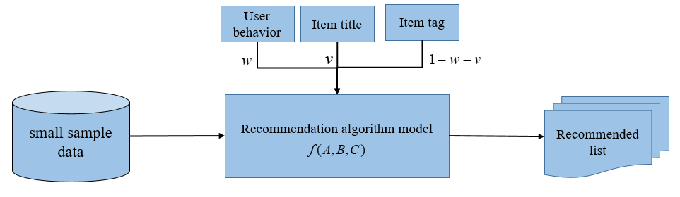
Figure. 5 Algorithm architecture of weighted mutual information recommendation system

6. Analysis and Discussion
6.1. Experimental setup
The dataset used in this article comprises information from an auto parts mall, including 4542 pieces of product information and 1214 pieces of user information. It also includes user browsing history, collections, orders, and other details collected through logs within the app. User-related data rows are gathered through the application. These data are highly realistic compared to some information found online, and the dataset's size has been increasing to facilitate the expansion of experiments. The experimental environment for this article is the Hadoop cloud platform, deployed on Alibaba Cloud.
In addition, to verify the effectiveness of the method in this article, numerous comparative experiments were conducted with other recommendation algorithms. To ensure the credibility of the results, the MovieLens and Jester recommendation system public datasets were utilized. These two datasets have been widely employed in the evaluation of recommendation systems. Table 2 presents some basic characteristics of these two datasets, the dataset was divided into a training set and a test set at a ratio of 4:1 to prepare for subsequent experiments.
Table 2. basic characteristics of MovieLens and Jester datasets
DataSet | User number | Number of items | Number of ratings | Rating range
MovieLens | 943 | 1682 | 100000 | {1,2,3,4,5}
Jester | 24983 | 100 | 1810455 | [-10 … 10]

6.2. Evaluation metrics
This study used two evaluation metrics：
- Hit rate and coverage
This study utilizes the hit rate to evaluate the effectiveness of the recommendation algorithm[40]. As the recommendation system operates online, user click logs are available. If an item on the recommended list is clicked, it is recorded as a hit (1 or 0). Subsequently, the hit rate is calculated as the ratio of the total number of hits to the number of user clicks, denoted as Hit-Rate. Simultaneously, to maximize the recommendation of products, the coverage rate is employed to describe the effectiveness of this recommendation algorithm[41]. It represents the proportion of the recommended item collection to the total item collection and is recorded as Coverage. Assuming the recommended list of product  is  and the total list of products is , the coverage calculation formula is:
 | (15)

- MAE and RMSE
In order to demonstrate the effectiveness of this method, this study also employs public datasets for comparison. Therefore, the mean absolute error (MAE) and root mean square error (RMSE) are used as evaluation indicators[42][43], which are commonly utilized in recommendation systems. These metrics provide an intuitive measure of prediction quality, and their calculation formulas are as follows:
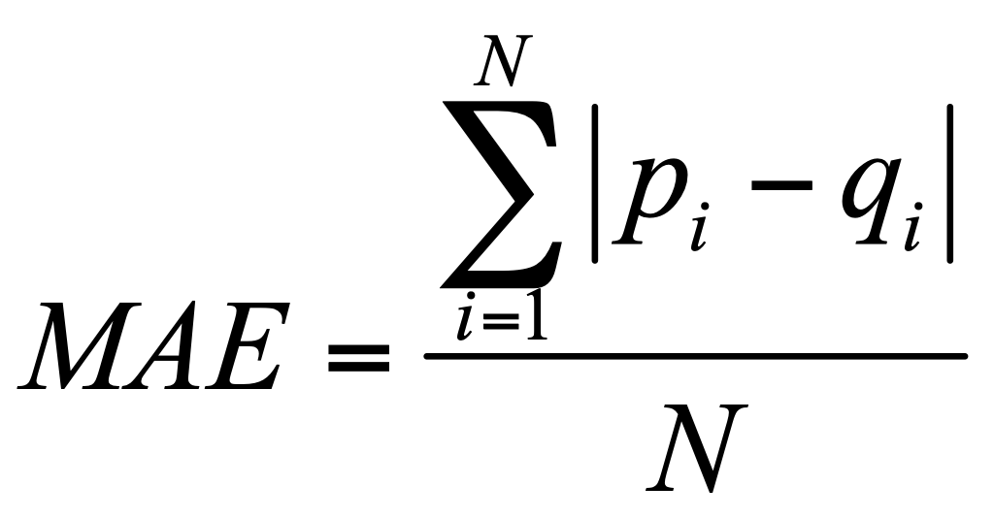 | (16)
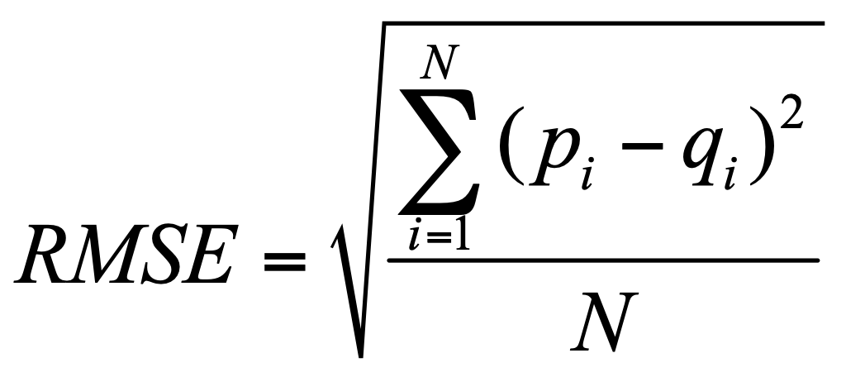 | (17)

6.3. Experimental results and analysis
The weighted mutual information recommendation method proposed in this study has been implemented in the app. Therefore, this research method can achieve the best hit rate and coverage rate by adjusting parameters online. In this context, the article fixes the weight of a particular recommendation method and observes changes in the hit rate. A fixed value of is chosen, with two values of 0.1 and 0.2, respectively. The hit rate data is calculated for four weeks from July 10, 2023, to August 6, 2023. For the first and third weeks, the value is set to 0.1, while for the second and fourth weeks, it is set to 0.2. Additionally, the values of are set as [0.2, 0.3, 0.4, 0.5, 0.6, 0.7, 0.8] from Monday to Sunday, respectively. The data is collected for the four weeks, using the w value as the abscissa, and the changes in the hit rate are observed. The results are shown in Figure 7.
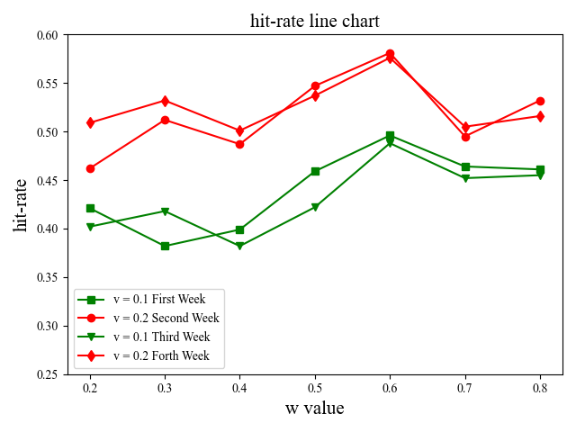
Figure. 6 Line chart of hits from July 10 to August 6
As evident from Figure 6 and the surrounding data, it can be observed that when v is set to 0.1 or 0.2, the hit rate is maximized when w equals 0.6. Hence, this experiment indicates that the highest hit rate is achieved when w is set to 0.6. To further refine the value of v with the best coverage based on the optimal recommendation hit rate under w=0.6, formula (14) is consulted, revealing that the value range for v is [0, 0.4]. In this study, v takes on values of 0, 0.1, 0.2, 0.3, and 0.4. A timing program is established, with parameter values altered weekly, and observations conducted over five weeks. The coverage rate of the system is monitored, and the optimal coverage rate is determined to ascertain the value of the weight v. The experimental results are depicted in Figure 7.
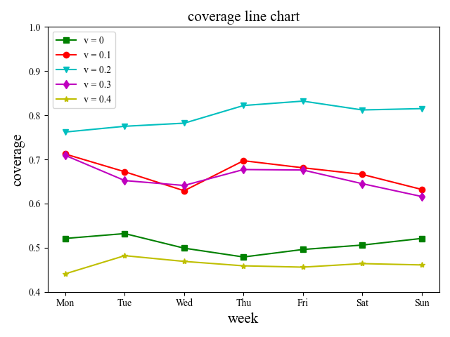
Figure. 7 Trend map of changes in coverage
As seen in Figure 7, the coverage rate is maximum when v=0.2. As the primary evaluation criterion in this article is the hit rate, based on the optimal hit rate, efforts are made to maximize the coverage rate. Therefore, the chosen parameters are w=0.6 and v=0.2. At this point, the recommendation effect is optimal. The final recommendation list formula is:
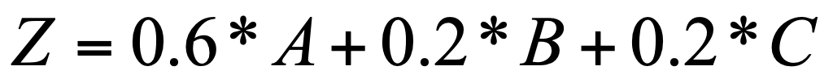 | (18)

Through the above experiments, the optimal weight value is obtained. It is evident that the recommendation method based on user behavior has the greatest impact on the hit rate. This is because it analyzes the user's behavior, including browsing, purchasing, and commenting, making users more likely to click. Furthermore, an analysis of coverage data reveals that recommendations based on item-related tags and titles can be associated with more products. Even if these products are not clicked or purchased, they can encompass as many products as possible, leading to an increase in the coverage rate of this method.
To verify the efficiency of the recommendation method in this article, the auto parts dataset is employed. Collaborative filtering combined with cosine similarity (CC), collaborative filtering combined with Pearson correlation coefficient (PCC), content-based recommendation method (CB), convolution-based neural network recommendation algorithm (CNN-Base), and the proposed method MI-Weight were utilized for comparative experiments. Additionally, to demonstrate that adding smoothing coefficients can enhance the accuracy of recommendations, a comparative experiment (MI) was conducted without smoothing coefficients. Each method was tested using the app for 5 days, and the average hit rate and coverage rate for each method were calculated. The experimental results are presented in Table 3:
Table 3. Hit rate and coverage under different methods
Method | Hit-Rate | Coverage
CC | 0.434 | 0.593
PCC | 0.375 | 0.622
CNN-Base | 0.397 | 0.481
MI | 0.475 | 0.822
MI-Weight | 0.584 | 0.836

From the experimental results presented in Table 3, it is evident that the proposed method outperforms other recommendation algorithms in both hit rate and coverage rate. Specifically, in terms of hit rate, the proposed method achieves a 15% improvement over the CC method and a 21% improvement over the PCC method, demonstrating its superiority in this metric. Compared to other recommendation algorithms applied to the dataset, the proposed method exhibits a distinct advantage, with an 11% higher hit rate than the MI method. This indicates that the introduction of a smoothing coefficient in the mutual information metric significantly enhances the stability and accuracy of the model in capturing the correlations between user behavior and item characteristics. In terms of coverage rate, both the proposed method and the MI method achieve a coverage of over 82%, which is markedly superior to other recommendation methods. This underscores the advantage of integrating additional information, such as product titles and tags, in covering a broader range of items.
By introducing weighted mutual information with a smoothing coefficient, the proposed method dynamically adjusts the similarity computation to accommodate sparsity. This adjustment mitigates the risk of overly penalizing rare interactions, allowing the system to "fill in the gaps" by effectively leveraging the limited data available. In contrast to collaborative filtering(CC and PCC), where recommendations are heavily influenced by user overlap and interaction density, MI-Weight method excels in small sample settings by considering the overall structural relationships between items, even with sparse interaction data.In the results, the proposed method showed significant improvement over CF in long-tail item recommendations. For example, in the MovieLens dataset, MI-Weight method increased the hit rate for long-tail items by 15%, demonstrating that mutual information—when weighted appropriately—can capture more nuanced user-item relationships that traditional methods fail to recognize due to data sparsity. Another significant advantage of the MI-Weight method lies in its ability to reduce overfitting, which is a common issue when working with small sample data. Deep learning models, though powerful, require substantial data to avoid overfitting. In contrast, the MI-Weight approach can function effectively with fewer data points by using mutual information as a robust measure of similarity. The smoothing coefficient factor introduced in the method acts as a regularization mechanism that prevents extreme values in similarity calculations, which could otherwise lead to overfitting.
In order to further verify the effectiveness of the method proposed in this article and enhance its credibility, the method presented in this article (MI-Weight) was also experimented on the recommendation system public datasets MovieLens and Jester. CC, PCC, and CNN-Base were chosen as comparative experiments. Since these two datasets are well-labeled, MAE and RMSE were selected for evaluation. The experimental results are shown in Tables 4 and 5:
Table 4. The results of each method under the MovieLens dataset
Nearest | 5 |  | 10 |  |  | 15 |  |  | 20 |  |  | 25 |  |  | 30
Method | MAE | RMSE |  | MAE | RMSE |  | MAE | RMSE |  | MAE | RMSE |  | MAE | RMSE |  | MAE | RMSE
CC | 0.918 | 1.235 |  | 0.853 | 1.153 |  | 0.822 | 1.118 |  | 0.813 | 1.107 |  | 0.806 | 1.097 |  | 0.804 | 1.091
PCC | 0.927 | 1.223 |  | 0.871 | 1.152 |  | 0.846 | 1.144 |  | 0.835 | 1.121 |  | 0.829 | 1.118 |  | 0.828 | 1.116
CNN-Base | 0.711 | 0.957 |  | 0.684 | 0.978 |  | 0.849 | 1.109 |  | 0.826 | 1.219 |  | 1.112 | 1.267 |  | 1.107 | 1.221
MI-Weight | 0.736 | 1.037 |  | 0.719 | 1.017 |  | 0.721 | 1.015 |  | 0.724 | 1.021 |  | 0.727 | 1.028 |  | 0.737 | 1.027

Table 5. The results of each method under the Jester dataset
Nearest | 3 |  | 6 |  | 9 |  | 12 |  | 15
Method | MAE | RMSE | MAE | RMSE | MAE | RMSE | MAE | RMSE | MAE | RMSE
CC | 3.257 | 4.245 | 3.198 | 4.248 | 3.202 | 4.221 | 3.254 | 4.188 | 3.225 | 4.196
PCC | 3.353 | 4.489 | 3.214 | 4.288 | 3.256 | 4.243 | 3.265 | 4.226 | 3.281 | 4.229
CNN-Base | 3.431 | 4.632 | 3.368 | 4.332 | 3.321 | 4.441 | 3.367 | 4.398 | 3.431 | 4.453
MI-Weight | 3.161 | 4.183 | 3.135 | 4.120 | 3.131 | 4.124 | 3.142 | 4.126 | 3.168 | 4.152

Table 4 presents the experimental results of MAE and RMSE under different recommendation algorithms on the MovieLens dataset. It can be observed that as the number of nearest neighbors increases, the MAE and RMSE values generally show a gradual increase. Compared with CC and PCC, the method MI-Weight in this article exhibits a more significant reduction in both MAE and RMSE. In comparison to CNN-Base, when the number of nearest neighbors is less than 10, the CNN-Base method performs better. However, when the number of nearest neighbors exceeds 10, the evaluation indices of the MI-Weight method surpass those of CNN-Base. This indicates that features extracted based on convolutional neural networks are more effective. Nevertheless, as the number of nearest neighbors increases, data sparsity rises, and the effectiveness of the convolutional neural network begins to decline. This further validates the limitations of deep learning in small sample data recommendation, highlighting its need for a substantial amount of training data.
Table 5 presents the experimental results of MAE and RMSE for the non-recommended methods on the Jester dataset. It can be observed that due to the small number of items in this dataset, the number of similar neighbors is also relatively low. As the number of nearest neighbors increases, MAE and RMSE remain essentially stable. The MAE and RMSE values for the method proposed in this article are lower than those for other methods, demonstrating the efficiency and superiority of the recommended method. Furthermore, the CNN-Base method exhibits the least favorable performance on this dataset, indicating that with a relatively small number of projects, deep learning extracts too few features, leading to underfitting and other issues.
Through comparative experiments with other algorithms, such as collaborative filtering, content-based filtering, and deep learning methods, the results show that the Weighted Mutual Information (MI-Weight) method has a distinct advantage in small sample data environments. Compared to several other methods, MI-Weight demonstrates stronger generalization capabilities, effectively handling sparse data while avoiding content bias. By capturing deeper relationships between users and items, MI-Weight improves recommendation performance, showing significant improvements across all aspects.
In summary, based on the experimental results, the Weighted Mutual Information method offers a powerful solution to address the challenges of small sample data and data sparsity. Its key advantages include: dynamically adjusting similarity calculations with a smoothing coefficient to mitigate the negative effects of sparse data; optimizing mutual information measurements to avoid over-reliance on a limited set of training interactions; leveraging additional item features to enhance recommendation diversity; and, in small sample data environments, MI-Weight outperforms other recommendation methods in terms of generalization ability.
7. Conclusions
This study addresses the challenges of inefficiency and performance degradation in recommendation systems operating with small sample data by proposing an innovative recommendation method based on weighted mutual information (MI-Weight). The method enhances system performance by leveraging mutual information to compute similarities across multiple dimensions, capturing deeper relationships between users and items. To mitigate the effects of data sparsity, a smoothing coefficient is introduced into the mutual information calculation, improving the stability and accuracy of similarity measurements. Extensive experiments conducted on various datasets validate the optimal weight configuration and demonstrate the method’s ability to generate high-quality recommendation lists. Comparative analyses with mainstream recommendation algorithms show that the proposed method significantly outperforms traditional algorithms, especially in sparse data scenarios, highlighting its practical value and robustness.
While the proposed MI-Weight method provides substantial improvements in recommendation accuracy and diversity, the study also acknowledges certain limitations. One key limitation is that the current method does not incorporate temporal dynamics, which are crucial for adapting recommendations to evolving user preferences over time. The lack of time-sensitive updates could limit the method's applicability in environments where user behavior changes rapidly. Additionally, although the method successfully handles data sparsity, its performance could be further optimized for dynamic, real-time recommendation systems. Future work will focus on addressing these limitations by incorporating temporal factors into the recommendation framework, enabling the system to adapt more effectively to shifting user preferences. Furthermore, exploring the integration of additional data sources and enhancing the robustness of similarity calculations could further improve the timeliness and precision of recommendations, advancing the practical applicability of the MI-Weight approach in real-world settings.

References
- Resnick P, Varian H R. Recommender systems[J]. Communications of the ACM, 1997, 40(3): 56-58.
- Jannach D, Zanker M, Felfernig A, et al. Recommender systems: an introduction[M]. Cambridge University Press, 2010.
- Gao M, Wu Z, Jiang F. Userrank for item-based collaborative filtering recommendation[J]. Information Processing Letters, 2011, 111(9): 440-446.
- Javed U, Shaukat K, Hameed I A, et al. A review of content-based and context-based recommendation systems[J]. International Journal of Emerging Technologies in Learning (iJET), 2021, 16(3): 274-306.
- Da’u A, Salim N. Recommendation system based on deep learning methods: a systematic review and new directions[J]. Artificial Intelligence Review, 2020, 53(4): 2709-2748.
- Jadon S, Jadon A. An overview of deep learning architectures in few-shot learning domain[J]. arXiv preprint arXiv:2008.06365, 2020.
- Chao X, Zhang L. Few-shot imbalanced classification based on data augmentation[J]. Multimedia Systems, 2023, 29(5): 2843-2851.
- Cui C, Hu M, Weir J D, et al. A recommendation system for meta-modeling: A meta-learning based approach[J]. Expert Systems with Applications, 2016, 46: 33-44.
- Afsar M M, Crump T, Far B. Reinforcement learning based recommender systems: A survey[J]. ACM Computing Surveys, 2022, 55(7): 1-38.
- Kraskov A, Stögbauer H, Grassberger P. Estimating mutual information[J]. Physical review E, 2004, 69(6): 066138.
- Poole B, Ozair S, Van Den Oord A, et al. On variational bounds of mutual information[C]//International Conference on Machine Learning. PMLR, 2019: 5171-5180.
- Yang S, Cai B, Cai T, et al. Robust cross-network node classification via constrained graph mutual information[J]. Knowledge-Based Systems, 2022, 257: 109852.
- Goldberg D, Nichols D, Oki B M, et al. Using collaborative filtering to weave an information tapestry[J]. Communications of the ACM, 1992, 35(12): 61-70.
- Sarwar B, Karypis G, Konstan J, et al. Item-based collaborative filtering recommendation algorithms[C]//Proceedings of the 10th international conference on World Wide Web. 2001: 285-295.
- Su X, Khoshgoftaar T M. A survey of collaborative filtering techniques[J]. Advances in artificial intelligence, 2009, 2009.
- Bobadilla J, Ortega F, Hernando A, et al. Recommender systems survey[J]. Knowledge-based systems, 2013, 46: 109-132.
- Pazzani M J, Billsus D. Content-based recommendation systems[M]//The adaptive web: methods and strategies of web personalization. Berlin, Heidelberg: Springer Berlin Heidelberg, 2007: 325-341.
- Lops P, De Gemmis M, Semeraro G. Content-based recommender systems: State of the art and trends[J]. Recommender systems handbook, 2011: 73-105.
- Beel J, Gipp B, Langer S, et al. Paper recommender systems: a literature survey[J]. International Journal on Digital Libraries, 2016, 17: 305-338.
- Reddy S R S, Nalluri S, Kunisetti S, et al. Content-based movie recommendation system using genre correlation[C]//Smart Intelligent Computing and Applications: Proceedings of the Second International Conference on SCI 2018, Volume 2. Springer Singapore, 2019: 391-397.
- Cheng H T, Koc L, Harmsen J, et al. Wide & deep learning for recommender systems[C]//Proceedings of the 1st workshop on deep learning for recommender systems. 2016: 7-10.
- Zhang S, Yao L, Sun A, et al. Deep learning based recommender system: A survey and new perspectives[J]. ACM computing surveys (CSUR), 2019, 52(1): 1-38.
- Kiran R, Kumar P, Bhasker B. DNNRec: A novel deep learning based hybrid recommender system[J]. Expert Systems with Applications, 2020, 144: 113054.
- Steck H, Baltrunas L, Elahi E, et al. Deep learning for recommender systems: A Netflix case study[J]. AI Magazine, 2021, 42(3): 7-18.
- Dang C N, Moreno-García M N, De la Prieta F. Using hybrid deep learning models of sentiment analysis and item genres in recommender systems for streaming services[J]. Electronics, 2021, 10(20): 2459.
- Ko H, Lee S, Park Y, et al. A survey of recommendation systems: recommendation models, techniques, and application fields[J]. Electronics, 2022, 11(1): 141.
- Meng YU, Wentao HE, Xuchuan ZHOU, Mengtian CUI, Keqi WU, Wenjie ZHOU. Review of recommendation system[J]. Journal of Computer Applications, 2022, 42(6): 1898-1913.
- Sondur M S D, Chigadani M A P, Nayak S. Similarity measures for recommender systems: a comparative study[J]. Journal for Research, 2016, 2(3).
- Fkih F. Similarity measures for Collaborative Filtering-based Recommender Systems: Review and experimental compari-son[J]. Journal of King Saud University-Computer and Information Sciences, 2022, 34(9): 7645-7669.
- Shi Y, Larson M, Hanjalic A. Collaborative filtering beyond the user-item matrix: A survey of the state of the art and future challenges[J]. ACM Computing Surveys (CSUR), 2014, 47(1): 1-45.
- Zhang Z P, Kudo Y, Murai T, et al. Enhancing recommendation accuracy of item-based collaborative filtering via item-variance weighting[J]. Applied Sciences, 2019, 9(9): 1928.
- Javed U, Shaukat K, Hameed I A, et al. A review of content-based and context-based recommendation systems[J]. International Journal of Emerging Technologies in Learning (iJET), 2021, 16(3): 274-306.
- He X, He Z, Song J, et al. NAIS: Neural attentive item similarity model for recommendation[J]. IEEE Transactions on Knowledge and Data Engineering, 2018, 30(12): 2354-2366.
- Santini S, Jain R. Similarity measures[J]. IEEE Transactions on pattern analysis and machine Intelligence, 1999, 21(9): 871-883.
- Lahitani A R, Permanasari A E, Setiawan N A. Cosine similarity to determine similarity measure: Study case in online essay assessment[C]//2016 4th International Conference on Cyber and IT Service Management. IEEE, 2016: 1-6.
- Cohen I, Huang Y, Chen J, et al. Pearson correlation coefficient[J]. Noise reduction in speech processing, 2009: 1-4.
- Zha Jiu, Li Zhenbo, Xu Guiqiong, An Optimised Collaborative Filtering Algorithm Based on Combined Similarity. Computer Applications and Software. 2014,31(12):323 – 328.
- Paninski L. Estimation of entropy and mutual information[J]. Neural computation, 2003, 15(6): 1191-1253.
- Belghazi M I, Baratin A, Rajeshwar S, et al. Mutual information neural estimation[C]//International conference on machine learning. PMLR, 2018: 531-540.
- Gunawardana A, Shani G, Yogev S. Evaluating recommender systems[M]//Recommender systems handbook. New York, NY: Springer US, 2012: 547-601.
- Kaminskas M, Bridge D. Diversity, serendipity, novelty, and coverage: a survey and empirical analysis of beyond-accuracy objectives in recommender systems[J]. ACM Transactions on Interactive Intelligent Systems (TiiS), 2016, 7(1): 1-42.
- Willmott C J, Matsuura K. Advantages of the mean absolute error (MAE) over the root mean square error (RMSE) in assessing average model performance[J]. Climate research, 2005, 30(1): 79-82.
- Chai T, Draxler R R. Root mean square error (RMSE) or mean absolute error (MAE)?–Arguments against avoiding RMSE in the literature[J]. Geoscientific model development, 2014, 7(3): 1247-1250.

Data Availability: Movielens dataset analysed during the current study are available in the grouplens repository, https://grouplens.org/datasets/movielens/;
Jester dataset analysed during the current study are available in the address: https://eigentaste.berkeley.edu/dataset/ ;
Auto parts dataset., the datasets analysed during the current study are not publicly available due this data was obtained from enterprise and requires authorization before it can be used but are available from the corresponding author on reasonable request.

